
Product Name: PROACTIVE
Target Market: Corporate Employee Benefit Only with a minimum of 10 employees.
Any identified markets for whom the product is not suitable: Companies outside of the UK/ Direct paying policyholders/ Groups with less than 10 employees.
Number | Assessment Question/ Category | Assessment
1. | Details of the nature of the product | Health Cash Plan.
2. | Coverage that the product provides. | Refer to Proactive Benefit Table and Terms & Conditions.
3. | Limitations in relation to coverage (including but not limited to exclusions, limits of liability, excesses) | RESTRICTIONS  - Annual Benefit allowances.  - Claims must be received within 26 weeks of the treatment date or date of accident.  - Dental Accident & Injury claims require attendance for a dental emergency appointment within five days of the accident or injury.  - A maximum of four dependent children are covered, at no extra cost, up to their 24th birthday if in full time education, claiming half of the adult entitlement for the benefits as specified on the benefit table.  NOT INSURED  - Treatment needed due to dangerous activities and sports, professional sports injuries or as a result of self-inflicted injuries.  - Treatment provided by immediate family.  - Treatments or benefits arranged, paid or facilitated through your employer or another employee.  - Any charges for completion of claim forms or any medical information we need to support policyholder claims.
4. | Type & quality of the services to be provided | Policyholders will have access to all the benefits specified on the benefit table. Optional extras in the form of Face to Face Counselling and PMI excess cover can be added by the employer in question if required. Only the employee can have face to face counselling, not a dependant or partner.  Access to the My Medicash app, providing easy claim submission, access to policy documents and ancillary services.  Customer support from Medicash by both telephone and email. Telephone lines are open 8am to 5pm, Monday to Friday (excluding bank holidays), with 70% of calls answered within 30 seconds and less than 5% abandoned. Emails are responded to within 2 working days.  Ancillary services are available 24/7 365 days a year.  Claims can be submitted through the website, by post or the My Medicash app.  Payment is ordinarily made by bank transfer using a fast payment service, meaning that following a claim being authorised, payment is credited into the policyholder’s bank account by the end of the following working day and often within 24 hours. Payment can also be made by cheque.  Practitioners can only be paid by cheque in relation to PMI claims.  The ‘Medicash Assist’ service is available for policyholders with characteristics of vulnerability (Medicash Assist | Medicash).
5. | Is the product net priced? | All premiums quoted include Insurance Premium Tax at the current rate.
6. | Total price to be paid by the policyholder | There is no direct cost to the policyholder as Proactive is provided as an employee benefit, paid for by the employer.  The cover is counted as a benefit in kind for tax purposes on the element provided by the employer.  Should the policyholder opt to increase to a higher level of cover, paying for the increase, they will be liable for this element of the premium paid, which includes Insurance Premium Tax (IPT).
7. | Details of the pricing model used to calculate the risk premium i) for the initial policy term, ii) for any future renewal | For new business, standard rates apply on a community underwritten basis. If a discounted plan is requested, then a risk based demographic approach is engaged.  If a group is switching a cash plan to Medicash, then the pricing model is based on risk analysis of claims data.  At policy anniversary, a review of claims data informs the risk approach to premium structure.
8. | Breakdown of the overall cost of the insurance product | Proactive has a tiered structure for premiums. There is a rate for groups insuring 10-24 employees and a different rate for groups of 25 employees or more.  The standard Proactive charges are shown at the end of this document.  For business transferred from a previous health cash plan insurer, claim history is requested and this may result in an uplift to the standard premiums offered.
9. | Details of the remuneration of each party in the distribution chain where this is part of the premium or otherwise paid directly by the customer | 10% is the standard commission rate payable to any broker as applicable. There is no additional remuneration in terms of direct sales to group entities.
10. | Are any changes expected to the total price a customer will pay during the period that they hold the product (including at the first or any subsequent renewal or any other point in time)? | See (6) for details of the price paid by the policyholder.  At policy anniversary, agreement will be sought between Medicash and the employer/ intermediary regarding renewal terms. This could result in renewal, renewal with a different price structure,  non-renewal or renewal on a different plan.
11. | Is any change to the insured risk expected over time, for example to the nature, financial value or a customers usage of an underlying good to which the insurance relates? | There is no change to the insured risk expected. The plan is provided as specified, with no changes built in. See question 14 for details of the situation at annual renewal.
12. | Is the number of expected claims that may be made, or financial value of any such claim, expected to change over time due to the nature of the product, the customer’s needs or any relevant features of the insured risk, for example i) as a result of expected depreciation in the value of the insured asset, ii) where the customer’s need or eligibility for certain cover may change for example in a customer’s usage? | There is nothing inherent built into the product which would result in expected claims variation or changes to policyholder needs and risk.
13. | Could the total premiums expected to be paid over the length of time a customer would hold the product, exceed the benefits that could be received from claims for example due to cover limits applying across the foreseeable period? | As this is an employee paid plan, there is no premium paid by the policyholder. A policyholder can opt to increase to a higher level of cover however, paying a fixed premium for this.
14. | Could benefits offered by the policy at inception be unavailable at subsequent renewals, due to exclusions or claim limits, without any commensurate reduction in the premium? | At annual renewal of the group contract, agreement will be sought between Medicash and the employer/ intermediary regarding renewal terms. This could result in renewal at the same price, renewal with a different price structure, non-renewal or renewal on a different plan.
15. | Could customers be discouraged from or unable to renew due to the level of ongoing premiums including increases at renewal meaning they may not be receiving the full intended benefits of the product? | At annual renewal of the group contract, agreement will be sought between Medicash and the employer/ intermediary regarding renewal terms. This could result in renewal, renewal with a different price structure,  non-renewal or renewal on a different plan.  Premiums are paid by the employer and not the policyholder, so in the event of any increase in premium, there is no effect on the value to the policyholder.

Costs
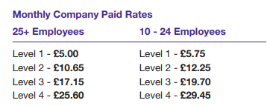
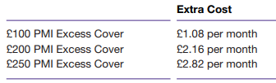
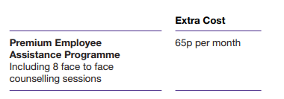

Yearly Update 2023:

1st September 2023 | A slight price increase for new quotes on or after 1st September 2023 has been introduced. This increase is the first since the Proactive plan was introduced in 2012, so over a decade of price stasis being maintained. The decision was taken due to the high costs of medical inflation and costs to Medicash’s business.  Not only is the increase in price the first for over 10 years but there have been benefit increases during this time as well as the addition of further services such as Skin Vision and Phio as well as enhancements to the mProve Yourself app. The prices are further based on unlimited Virtual GP appointments for all adults covered.  With this in mind it has been assessed that this slight increase in price, the first for over 10 years, does not compromise the fair value of the product. For ease of comparison the previous price structure can be found as appendix one below.  The cost of EAP and PMI bolt ons remain unchanged.

Appendix 1: Proactive price structure 2012 to 31st August 2023

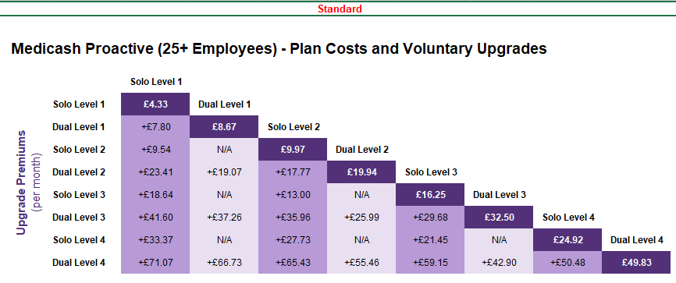
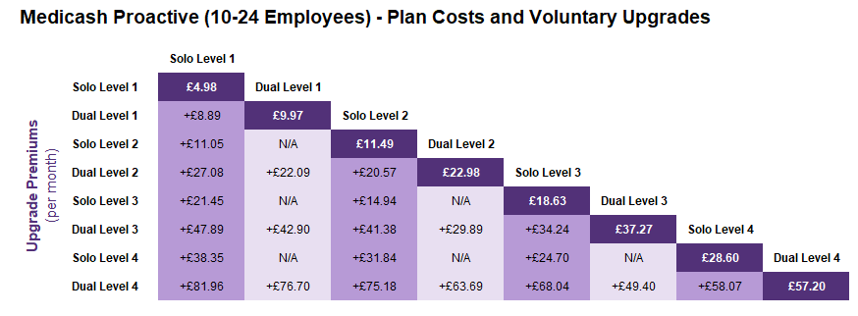
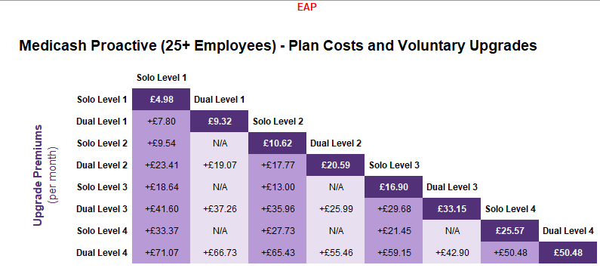
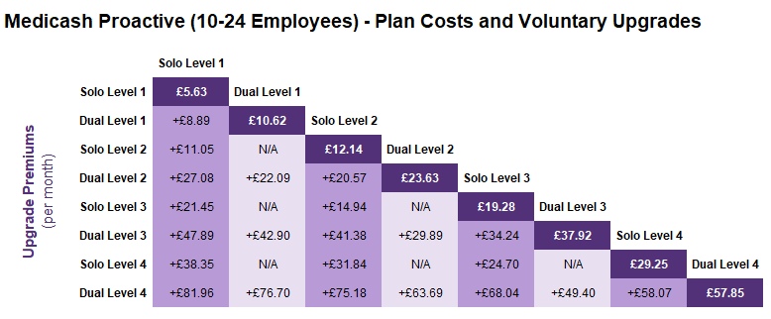

Yearly update 2024

A new suite of rates have been introduced for companies of 100 or more employees, offering lower costs for groups in this category, with no change to the benefits and service offered by the plan. There have also been some slight price increases to the 10-24 range and 25 plus. PMI and EAP bolt on rates remain the same.

100+ staff

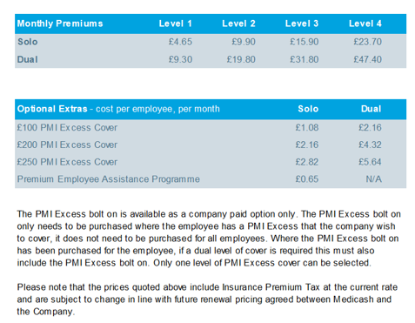

The 3 bands

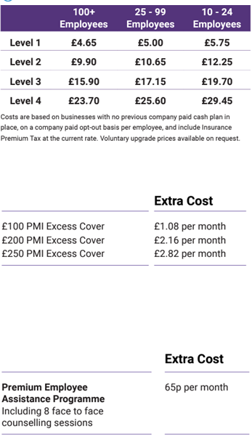

Fair value assessment satisfactorily completed: YES

If ‘N’, mitigating actions to be detailed below.

Version date: 1st September 2024

Next review date: 1 September 2025

