
Fair Value Product Assessment.
Product Name: Medicash Plus
Target Market: Corporate employee benefit only, with a minimum of 25 employees.
Any identified markets for whom the product is not suitable: Companies outside of the UK/ Direct paying policyholders/ Groups with less than 25 employees.
Number | Assessment Question/ Category | Assessment
1. | Details of the nature of the product | Health Cash Plan.
2. | Coverage that the product provides. | Refer to Plus benefit table and Terms & Conditions.
3. | Limitations in relation to coverage (including but not limited to exclusions, limits of liability, excesses) | RESTRICTIONS  - Annual Benefit allowances.  - Claims must be received within 26 weeks of the treatment date or date of accident.  - Dental Accident & Injury claims require attendance for a dental emergency appointment within five days of the accident or injury.  - A maximum of four dependent children are covered at no extra cost, up to their 24th birthday if in full time education, claiming half of the adult entitlement for the benefits as specified on the benefit table.  NOT INSURED  - Treatment provided by immediate family.  - Treatments or benefits arranged, paid or facilitated through your employer or another employee.  - Any charges for completion of claim forms or any medical information we need to support your claim.
4. | Type & quality of the services to be provided | Policyholders will have access to all the benefits specified on the benefit table. Optional extras in the form of Face to Face Counselling and PMI excess cover can be added by the employer in question on request by your employer, with an additional premium paid.  Access to the My Medicash app, providing easy claim submission, access to policy documents and ancillary services.  Customer support from Medicash by both telephone and email. Telephone lines are open 8am to 5pm, Monday to Friday (excluding bank holidays), with 70% of calls answered within 30 seconds and less than 5% abandoned. Emails are responded to within 2 working days.  Ancillary services are open 24/7 365 days a year.  Claims can also be submitted through the Medicash website.  Claims can be submitted by post.  Payment is ordinarily made by bank transfer using a fast payment service, meaning that following a claim being authorised, payments are credited to the policyholder’s bank account by the end of the following working day and often within 24 hours. Payment can also be made by cheque if this is preferred.  The ‘Medicash Assist’ service is available for policyholders with characteristics of vulnerability (Medicash Assist | Medicash).
5. | Is the product net priced? | All premiums quoted include Insurance Premium Tax at the current rate.
6. | Total price to be paid by the customer | There is no direct cost to the policyholder as Plus is provided as an employee benefit, paid for by the employer.  The cover is counted as a benefit in kind for tax purposes on the element provided by the employer.  Should the policyholder opt to increase to a higher level of cover, paying for the increase, they will be liable for this element of the premium paid, which includes Insurance Premium Tax (IPT).
7. | Details of the pricing model used to calculate the risk premium i) for the initial policy term, ii) for any future renewal | For virgin business, standard rates apply on a community underwritten basis. If a bespoke or discounted plan is requested, then a risk based demographic approach is engaged.  If a group is switching a cash plan to Medicash, then the pricing model is based on risk analysis of claims data.  At policy anniversary, a review of claims data informs the risk approach to premium structure.
8. | Breakdown of the overall cost to the firm of the insurance product | The standard Plus charges are detailed at the end of this document.  For business transferred from a prior health cash plan insurer, claim history is requested and this may result in an uplift to the standard premiums offered.
9. | Details of the remuneration of each party in the distribution chain where this is part of the premium or otherwise paid directly by the customer | 10% is the standard commission rate payable to any broker as applicable. There is no additional remuneration in terms of direct sales to group entities.  Medicash’s sales team are bonused, based on targets.
10. | Are any changes expected to the total price a customer will pay during the period that they hold the product (including at the first or any subsequent renewal or any other point in time?) | At annual renewal of the group contract, agreement will be sought between Medicash and the employer/ intermediary regarding renewal terms. This could result in renewal with no price changes, renewal with a different price structure,  non-renewal or renewal on a different plan.
11. | Is any change to the insured risk expected over time, for example to the nature, financial value or a customers usage of an underlying good to which the insurance relates? | There is no change to the insured risk expected. The plan is provided as specified, with no changes built in. See question 10 for details of the situation at annual renewal.
12. | Is the number of expected claims that may be made, or financial value of any such claim, expected to change over time due to the nature of the product, the customer’s needs or any relevant features of the insured risk, for example i) as a result of expected depreciation in the value of the insured asset, ii) where the customer’s need or eligibility for certain cover may change for example in a customer’s usage? | There is nothing inherent built into the product which would result in expected claims variation or changes to policyholder needs and risk.
13. | Could the total premiums expected to be paid over the length of time a customer would hold the product, exceed the benefits that could be received from claims for example due to cover limits applying across the foreseeable period? | As this is a company paid plan, there is no premium paid by the policyholder. A policyholder can opt to increase to a higher level of cover however, paying a fixed premium for this.
14. | Could benefits offered by the policy at inception not be available at subsequent renewals, due to exclusions or claim limits, without any commensurate reduction in the premium? | At annual renewal of the group contract, agreement will be sought between Medicash and the employer/ intermediary regarding renewal terms. This could result in renewal, renewal with a different price structure, non-renewal or renewal on a different plan.
15. | Could customers be discouraged from or unable to renew due to the level of ongoing premiums including increases at renewal meaning they may not be receiving the full intended benefits of the product. | At annual renewal of the group contract, agreement will be sought between Medicash and the employer/ intermediary regarding renewal terms. This could result in renewal with no change to price, renewal with a different price structure,  non-renewal or renewal on a different plan.  Premiums are paid by the employer and not the policyholder, so in the event of any increase in premium, there is no effect on the value to the policyholder.

Standard charges:-

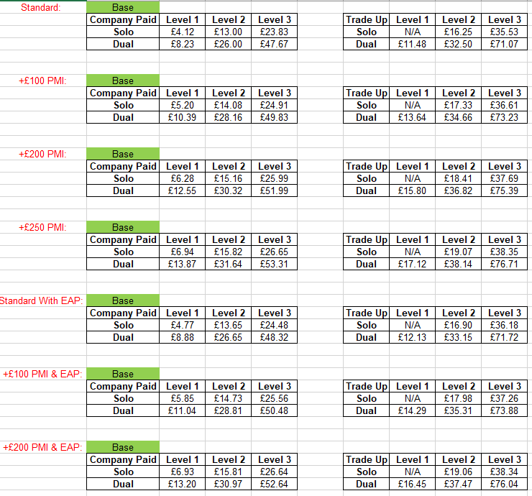

Fair value assessment satisfactorily completed: YES

If ‘N’, mitigating actions to be detailed below.

Version date: 3 November 2025

Next review date: 3 November 2026

Yearly Update:-

1 September 2023 | No changes to cover or any significant variance to outcomes since previous review.
1 September 2024 | No changes to cover or any significant variance to outcomes since previous review.
3 November 2025 | As of 1 March 2025 two new ancillary digital health benefits were added to this product which can be accessed by those users who have registered for the My Medicash App.  HealthLens  HealthLens is a digital health monitoring tool that uses smartphone cameras to measure key health indicators such as heart rate and blood pressure. Results are analysed to provide a personal health score and early insights into potential risks. Regular scans help track long-term health trends.  Eargym  Eargym provides interactive hearing training exercises to improve listening skills and auditory focus. The programme helps strengthen the brain’s ability to process sound, particularly in noisy environments. Over 80% of users have reported improvement to hearing ability within seven weeks of using Eargym.  These additions further increase the value of the plan for consumers as they will have access to more every day and useful proactive benefits at no additional cost to them.

